CURRICULUM VITAE

VU DUY KHUONG
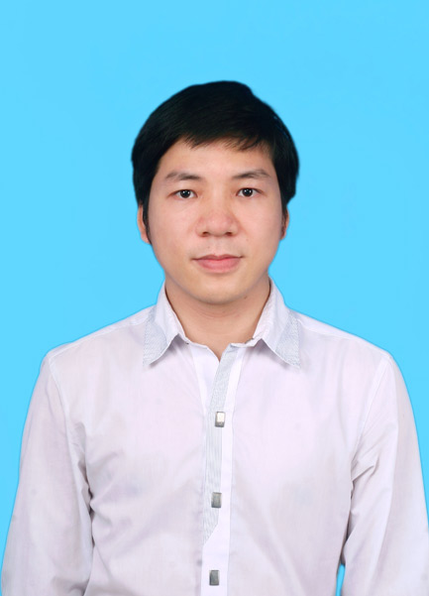Paste your photo here)

PERSONAL DETAILS

- Name VU DUY KHUONG
- Nationality Vietnamese
- Date of Birth December, 14th 1984
- Sex Male
- Phone No. (84) 988 303 217
- Email vuduykhuong1412@gmail.com

EDUCATIONAL BACKGROUND
- 2003 – 2006 : B.S in Electronics and Telecommunications – HaNoi University of Science and Technology
- 2008 – 2012 : B.S in Information Technology – National Economics University – VietNam
- 2014 – 2016 : Master in Information Technology – VNU University of Engineering and Technology

CERTIFICATE AND AWARD

- Certificate TOEIC – 520
- Japanese language ( primary, basic level)
- Third prize about chemical in Thai Binh province
- Scientific article: Efficient Region-of-Interest Based Adaptive Bit Allocation for 3D-TV Video Transmission over Networks”, VNU Journal of Science: Comp. Science & Com. Eng., Vol. 32, No. 1 (2016) 1-9

PROFESSIONAL SUMMARY

- Highly skilled IT professional with 6 years professional experience including application development, implementation, deployment, internal and customer support.
- Performed several roles as project manager, senior developer.
- Have consistently contributed to company’s growth and profitability by combining strong technical, management knowledge and with a dedicated proactive approach.
- Cooperative and able to perform within a team-oriented atmosphere
- Excellent English about reading, writing, communicating

SOFTWARE

- Databases etc: Oracle, PL/SQL, MS SQL Server 2005 -2008, My SQL
- Programming Languages: C#, VB, PHP, Java, XML, T-SQL, PL/SQL, C, C++ , Pascal
- Web: X/HTML5, CSS3, JavaScript, Boostrap 3; SASS/LESS
- OpenSource : Magento, Wordpress, Prestashop, OpenCart, Shopify
- Programming Tools: Visual Studio 6.0(Foxpro,VB…) / Visual Studio 2008 (VC++; C#,ASP), Eclipse, NetBean, Microsoft Visio, FTP Cute, Dreamweaver
- App server / Middleware: Microsoft IIS, Wamp, Xammp
- Framework: .NET, PHP
- Configuration Management tools: VSS, Visual SVN
- Browsers: IE 7-8-9, Firefox 39,40,..
- OOAD/OOP: Object Oriented Analysis (OOA), Object Oriented Design (OOD), Object Oriented Programming (OOP), Unified Modeling Language (UML)

PROFESSIONAL EXPERIENCE

2017/01 – Now
Software Tester Engineer
Panasonic R&D Center VietNam Co.,Ltd.

Job Description:
    - Testing - CUnit (Test BlackBox; WhiteBox; Unit Test) for these projects about automotive in car from Japan (M7G-Navi DB2; M7G-MCstd; ASEAN…) by C/C++ in Linux/Cywin
    - Testing – GoogleTest for project M7g-Audio in Car by C++ in Linux/Cywin
    - Have knowledge in AUTOSAR, ECU,…
    - Convert source C++ into C in enviroment development
    - Developing modules to support to test
    - Fix error for functions in project
Team size: 9 people

Responsibilities:
- Analyze the requirement
- Convert C++ into C and unit testing ( BlackBox and WhiteBox )
- Fix errors for functions in project

Technologies Used:
Hardware environment
• Windows
Software environment
• Cywin; Linux
Development tools
• Eclipse/ NotePad++/VBA
- SVN/Git/GitHub
- Cywin
Programming Language:
- C/C++
- PL/SQL, MySQL, DB2

2012/12– 2017/01

Front-end Developer

BrainOs Company Limited

Job Description:
- Programme Front-end website using open source as Wordpress, Magento, Prestashop,…
- Proficient in Javascript, CSS3, HTML5, SASS/LESS/Boostrap 3.0; 4.0, MySQL, PHP
- Proficient in using PhotoShop; Use Redmine for team; manage source code by SVN
- Programme function with customer’s request
- Convert PSD into Web with Responsive Design, do theme for open source with W3C standard
- Have knowledge about AngularJs2; ReactJS
- Fix browser compatibility issues using FileZilla, Firebug, HelpDesk, CuteFTP..v.v.
- Customer support including installation, edit, fix errors, customize according to the customer needs to install the company's products
- Understand the basic architecture and operation of the Magento E-commerce websites

Team size: 5 people

Responsibilities:
- Analyze the requirement
- Design , Install, Customize as customer’s needs
- Coding and unit testing

Technologies Used:
Hardware environment
• Windows
Software environment
• .NET Framework
Development tools
• NetBean/ NotePad++
- Visual SourceSafe
- FTP FileZilla
- Xampp 2.1
Programming Language:
- PHP
- PL/SQL, MySQL

2011/12– 2012/12

Programmer

ETC Company Limited

Job Description:
- Programme on the POS payment devices in the language C / C + + ,On Linux using C / C + + on Linux
- Programme the bank transactions (Sale, Debit, Void, etc.) according to ISO 8583 of HyperCom
- Programme project which integrated controller, pump head with POS payment device of PG Bank and Petrolimex Group
- Test banking transactions between the POS and host
- Programme the EMV chip card transactions (sale transaction, fallback)
- Design TMS for banks (Terminal, Acquirer, Issuier, Card Range)
- Fix the error transactions from POS to host returns
- Implement (installation, test, configuration, etc.) models VX510 VeriFone for VietComBank; Wcreon of the Spectra for PG Bank; ...
- Understand about chip card technology, magnetic card, NCC, about banking Host Gate Way, SmartSpy ....
- Other tasks ... etc
Team size: 5 people

Technologies Used:

Hardware environment
• Window, Linux
Software environment
• .NET Framework 2.0/ SQL 2008
Development tools
• Eclipse
Programming Language:
- C/C++ base

2011/06– 2011/12

Staff

DTSOFT SoftWare Company Limited

Job Description:
- Survey after sales service support system of joint-stock company DTSOFT
-Develop, design, complete Hospital Management Software, Solutions about Hospital (include 4 modules: Institute of charge and pharmacy; clinical records; Accounting; Human Resources)
-Programming. NET (C #) (reporting, programming, etc.) with ACCESS 2003 (VBA programming), Database SQL SERVER 2005 (hereinafter store, trigger ...)
- Analyze, design software management, Asset Management ...
- Support and maintenance for client (install, fix ...)
-Demo, Product Marketing Company (offers; looking for customers)
- Write the DLL library (VC + + 6.0), the normalized function for search
- Other work .... etc.. (Administrative work)

Team size: 6 people

Technologies Used:

Hardware environment
• Window
Software environment
• .NET Framework 2.0,3.0..
Development tools
• Access 2003/Microsoft SQL 2005
Programming Language:
- C#/Microsoft SQL 2003

I certify that the information provided above is completely true and sufficient. I agree the Company can verify the statements I have made​​. I would take full responsibility if the information is untrue.

...Ha Noi.., Date ..01..... Month ...12.. Year ...2018...

The applicant
(Sign and write your name)

Khuong
Vu Duy Khuong

